**Project Plan**

Project Description

…

Project Objectives

…

Project Schedule

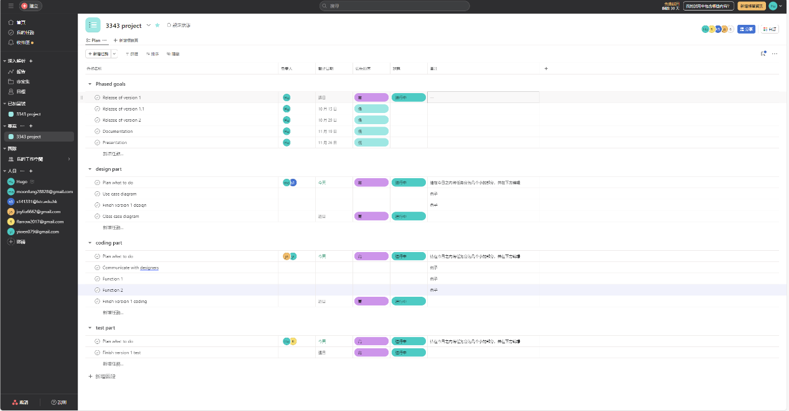

Work Breakdown Structure（WBS）

1. Topic Selection and Discussion

2. Design

2.1. User Interface Design

2.2. Use Case Design

2.3. Class Case Design

3. Development

3.1. Phase 1

3.1.1. Basic Function Implementation

3.2. Phase 2

3.2.1. Other Function Extensions

3.3. Phase 3

3.3.1.GUI

4. Testing

4.1. SIT

4.2. UAT

5. Documentation

5.1. Analysis and Design report

5.2. Project Plan

5.3. Bug Report

5.4. Test Report

5.5. Self-assessment Report